AM IL LAB EXERCISE-1

BFS

pip install networkx matplotlib

import networkx as nx

import matplotlib.pyplot as plt

def bfs(graph, start_node):

visited = set()

queue = [start_node]

visited.add(start_node)

bfs_order = [start_node]

while queue:

node = queue.pop(0)

for neighbor in graph.neighbors(node):

if neighbor not in visited:

queue.append(neighbor)

visited.add(neighbor)

bfs_order.append(neighbor)

return bfs_order

G = nx.DiGraph()

G.add_edge(0, 1)

G.add_edge(0, 3)

G.add_edge(1, 2)

G.add_edge(1, 3)

G.add_edge(2, 1)

G.add_edge(2, 3)

G.add_edge(3, 3)

start_node = 2

bfs_order = bfs(G, start_node)

print("BFS starting from vertex 2:", bfs_order)

pos = nx.spring_layout(G)

nx.draw(G, pos, with_labels=True, node_color='lightblue', node_size=600)

plt.title("BFS Visualization")

plt.show()

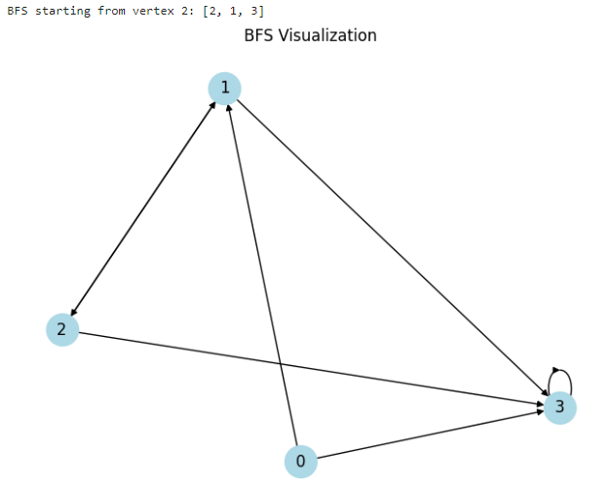

DFS

pip install networkx matplotlib

import matplotlib.pyplot as plt

import networkx as nx

class Graph:

def __init__(self):

self.graph = {}

def add_edge(self, u, v):

if u not in self.graph:

self.graph[u] = []

self.graph[u].append(v)

def dfs(self, start):

visited = set()

dfs_order = []

def dfs_recursive(node):

visited.add(node)

dfs_order.append(node)

for neighbor in self.graph.get(node, []):

if neighbor not in visited:

dfs_recursive(neighbor)

dfs_recursive(start)

return dfs_order

def visualize_dfs(graph, dfs_order):

G = nx.DiGraph()

for node, neighbors in graph.graph.items():

for neighbor in neighbors:

G.add_edge(node, neighbor)

pos = nx.spring_layout(G)

labels = {node: node for node in G.nodes()}

node_colors = ['blue' if node in dfs_order else 'gray' for node in G.nodes()]

nx.draw(G, pos, labels=labels, node_color=node_colors, with_labels=True, arrows=True)

plt.show()

# Example usage:

g = Graph()

g.add_edge(0, 1)

g.add_edge(0, 3)

g.add_edge(1, 2)

g.add_edge(1, 3)

g.add_edge(2, 1)

g.add_edge(2, 3)

g.add_edge(2, 4)

g.add_edge(3, 3)

start_node = 2

dfs_order = g.dfs(start_node)

print("DFS starting from vertex 2:")

print(dfs_order)

visualize_dfs(g, dfs_order)

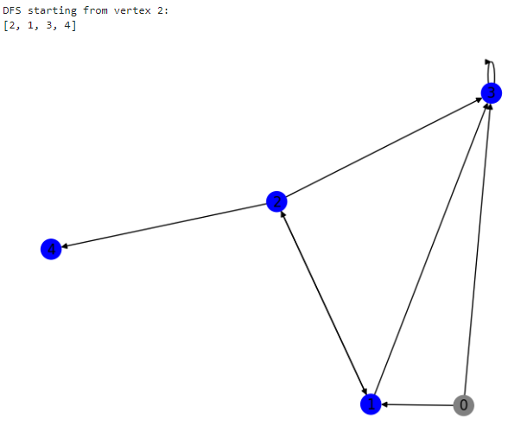

EX-2

import heapq

class PriorityQueue:

def __init__(self, priorityFunction):

self.priorityFunction = priorityFunction

self.heap = []

def push(self, item):

heapq.heappush(self.heap, (self.priorityFunction(item), item))

def pop(self):

(_, item) = heapq.heappop(self.heap)

return item

def empty(self):

return len(self.heap) == 0

def astarGraphSearch(problem, heuristic):

def totalCost(state):

return len(state[1]) + heuristic(state)

return graphSearch(problem, PriorityQueue(totalCost))

def pacmanPathFinder(problem, food):

def manhattanDistanceHeuristic(state):

return abs(state[0][0] - food[0]) + abs(state[0][1] - food[1])

return astarGraphSearch(problem, manhattanDistanceHeuristic)

# The code for the Node class is missing.

# Here's a corrected and complete version of your code for the Node class and A* search:

class Node:

def __init__(self, parent=None, position=None):

self.parent = parent

self.position = position

self.g = 0

self.h = 0

self.f = 0

def __eq__(self, other):

return self.position == other.position

def astar(maze, start, end):

start_node = Node(None, start)

start_node.g = start_node.h = start_node.f = 0

end_node = Node(None, end)

end_node.g = end_node.h = end_node.f = 0

open_list = []

closed_list = []

open_list.append(start_node)

while len(open_list) > 0:

current_node = open_list[0]

current_index = 0

for index, item in enumerate(open_list):

if item.f < current_node.f:

current_node = item

current_index = index

open_list.pop(current_index)

closed_list.append(current_node)

if current_node == end_node:

path = []

current = current_node

while current is not None:

path.append(current.position)

current = current.parent

return path[::-1]

children = []

for new_position in [(0, -1), (0, 1), (-1, 0), (1, 0), (-1, -1), (-1, 1), (1, -1), (1, 1)]:

node_position = (current_node.position[0] + new_position[0], current_node.position[1] + new_position[1])

if (

node_position[0] > len(maze) - 1

or node_position[0] < 0

or node_position[1] > len(maze[len(maze) - 1]) - 1

or node_position[1] < 0

):

Continue

if maze[node_position[0]][node_position[1]] != 0:

continue

new_node = Node(current_node, node_position)

children.append(new_node)

for child in children:

for closed_child in closed_list:

if child == closed_child:

continue

child.g = current_node.g + 1

child.h = (child.position[0] - end_node.position[0]) ** 2 + (child.position[1] - end_node.position[1]) ** 2

child.f = child.g + child.h

for open_node in open_list:

if child == open_node and child.g > open_node.g:

continue

open_list.append(child)

def main():

maze = [

[0, 0, 0, 0, 1, 0, 0, 0, 0, 0],

[0, 0, 0, 0, 1, 0, 0, 0, 0, 0],

[0, 0, 0, 0, 1, 0, 0, 0, 0, 0],

[0, 0, 0, 0, 1, 0, 0, 0, 0, 0],

[0, 0, 0, 0, 1, 0, 0, 0, 0, 0],

[0, 0, 0, 0, 0, 0, 0, 0, 0, 0],

[0, 0, 0, 0, 1, 0, 0, 0, 0, 0],

[0, 0, 0, 0, 1, 0, 0, 0, 0, 0],

[0, 0, 0, 0, 1, 0, 0, 0, 0, 0],

[0, 0, 0, 0, 0, 0, 0, 0, 0, 0],

]

start = (0, 0)

end = (7, 6)

path = astar(maze, start, end)

print("Path:", path)

if __name__ == "__main__":

main()

OUTPUT:

Path: [(0, 0), (1, 1), (2, 2), (3, 3), (4, 3), (5, 4), (6, 5), (7, 6)]

EX-6

import numpy as np

import matplotlib.pyplot as plt

import pandas as pd

from sklearn.model_selection import train_test_split

from sklearn.preprocessing import StandardScaler

from sklearn.naive_bayes import GaussianNB

from sklearn.metrics import confusion_matrix

from matplotlib.colors import ListedColormap

# Importing the dataset

dataset = pd.read_csv('G:\AI ML\diabetes.csv')

X = dataset.iloc[:, [0, 7]].values

y = dataset.iloc[:, 8].values

# Splitting the dataset into the Training set and Test set

x_train, x_test, y_train, y_test = train_test_split(X, y, test_size=0.33, random_state=42)

# Feature Scaling

sc = StandardScaler()

x_train = sc.fit_transform(x_train)

x_test = sc.transform(x_test)

# Fitting Naive Bayes to the Training set

classifier = GaussianNB()

classifier.fit(x_train, y_train)

# Predicting the Test set results

y_pred = classifier.predict(x_test)

# Making the Confusion Matrix

cm = confusion_matrix(y_test, y_pred)

print("Confusion Matrix: \n", cm)

# Visualizing the Training set results

x_set, y_set = x_train, y_train

X1, X2 = np.meshgrid(np.arange(start=x_set[:, 0].min() - 1, stop=x_set[:, 0].max() + 1, step=0.01),

np.arange(start=x_set[:, 1].min() - 1, stop=x_set[:, 1].max() + 1, step=0.01))

plt.contourf(X1, X2, classifier.predict(np.array([X1.ravel(), X2.ravel()]).T).reshape(X1.shape),

alpha=0.75, cmap=ListedColormap(['purple', 'green']))

plt.xlim(X1.min(), X1.max())

plt.ylim(X2.min(), X2.max())

for i, j in enumerate(np.unique(y_set)):

plt.scatter(x_set[y_set == j, 0], x_set[y_set == j, 1],

color=ListedColormap(['purple', 'green'])(i), label=j)

plt.title("Naive Bayes (Training set)")

plt.xlabel('Age')

plt.ylabel('Diabetic')

plt.legend()

plt.show()

# Visualizing the Test set results

x_set, y_set = x_test, y_test

X1, X2 = np.meshgrid(np.arange(start=x_set[:, 0].min() - 1, stop=x_set[:, 0].max() + 1, step=0.01),

np.arange(start=x_set[:, 1].min() - 1, stop=x_set[:, 1].max() + 1, step=0.01))

plt.contourf(X1, X2, classifier.predict(np.array([X1.ravel(), X2.ravel()]).T).reshape(X1.shape),

alpha=0.75, cmap=ListedColormap(['purple', 'green']))

plt.xlim(X1.min(), X1.max())

plt.ylim(X2.min(), X2.max())

for i, j in enumerate(np.unique(y_set)):

plt.scatter(x_set[y_set == j, 0], x_set[y_set == j, 1],

color=ListedColormap(['purple', 'green'])(i), label=j)

plt.title("Naive Bayes (Test set)")

plt.xlabel('Age')

plt.ylabel('Diabetic')

plt.legend()

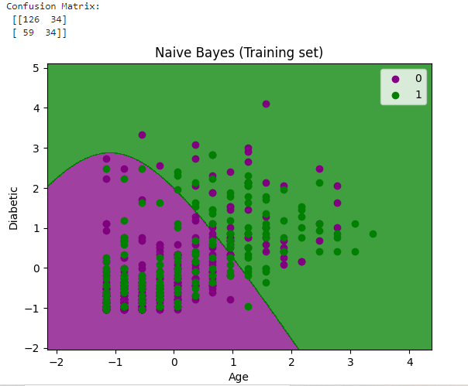plt.show()

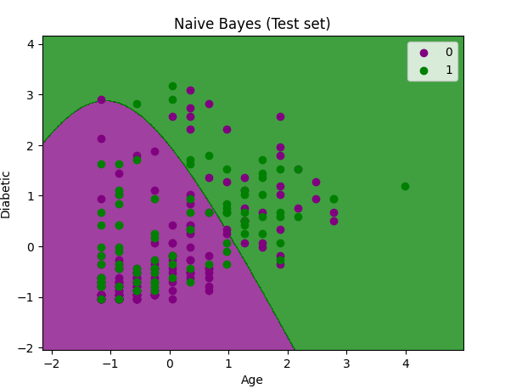

EX-7

import numpy as np

import pandas as pd

import sys

sys.executable

from pgmpy.estimators import MaximumLikelihoodEstimator

from pgmpy.models import BayesianNetwork

from pgmpy.inference import VariableElimination

# Load the Heart Disease dataset from a CSV file

heart_disease = pd.read_csv('G:\AI ML\heart.csv')

# Replace missing values with NaN using NumPy

heart_disease.replace('?', np.nan, inplace=True)

# Display sample instances from the dataset

print("Sample instances from the dataset are given below:")

print(heart_disease.head())

# Display attributes and their data types

print("\nAttributes and datatypes:")

print(heart_disease.dtypes)

# Define the structure of the Bayesian Network

model = BayesianNetwork([('age', 'heartdisease'), ('gender', 'heartdisease'),

('exang', 'heartdisease'), ('cp', 'heartdisease'),

('heartdisease', 'restecg', 'chol')])

print("\nLearning CPD using Maximum Likelihood Estimators")

# Fit the model to the data using Maximum Likelihood Estimation

model.fit(heart_disease, estimator=MaximumLikelihoodEstimator)

print("\nInferencing with Bayesian Network:")

# Create an inference object using Variable Elimination

heart_disease_infer = VariableElimination(model)

# 1. Probability of Heart Disease given evidence - restecg

q1 = heart_disease_infer.query(variables=['heartdisease'], evidence={'restecg': 1})

print("1. Probability of Heart Disease given evidence - restecg")

print(q1)

# 2. Probability of Heart Disease given evidence - cp

q2 = heart_disease_infer.query(variables=['heartdisease'], evidence={'cp': 2})

print("\n2. Probability of Heart Disease given evidence - cp")

print(q2)

EX-8

# Import the necessary libraries

import numpy as np

import pandas as pd

import matplotlib.pyplot as plt

from sklearn import datasets

from sklearn.mixture import GaussianMixture

# Load the Iris dataset

iris = datasets.load_iris()

# Select the first two columns (features) of the dataset

X = iris.data[:, :2]

# Create a DataFrame from the selected features

df = pd.DataFrame(X, columns=['Feature 1', 'Feature 2'])

# Plot the data

plt.scatter(df['Feature 1'], df['Feature 2'])

# Initialize a Gaussian Mixture Model with 3 components

gmm = GaussianMixture(n_components=3)

# Fit the GMM model to the dataset

gmm.fit(df)

# Assign a cluster label to each sample

labels = gmm.predict(df)

# Add the labels to the DataFrame

df['Labels'] = labels

# Separate the data into clusters based on the labels

cluster_0 = df[df['Labels'] == 0]

cluster_1 = df[df['Labels'] == 1]

cluster_2 = df[df['Labels'] == 2]

# Plot the three clusters with different colors

plt.scatter(cluster_0['Feature 1'], cluster_0['Feature 2'], c='r', label='Cluster 0')

plt.scatter(cluster_1['Feature 1'], cluster_1['Feature 2'], c='y', label='Cluster 1')

plt.scatter(cluster_2['Feature 1'], cluster_2['Feature 2'], c='g', label='Cluster 2')

# Print the converged log-likelihood value

print("Converged Log-Likelihood Value:", gmm.lower_bound_)

# Print the number of iterations needed for convergence

print("Number of Iterations to Converge:", gmm.n_iter_)

# Add labels and legend

plt.xlabel('Feature 1')

plt.ylabel('Feature 2')

plt.legend()

plt.show()

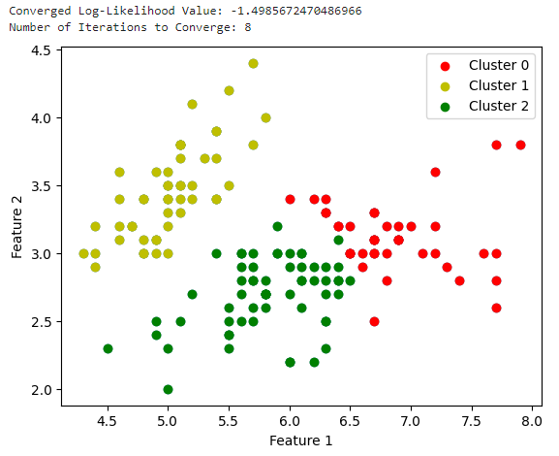

EX-9

from random import seed

from random import randrange

from csv import reader

from math import sqrt

import numpy as np

import matplotlib.pyplot as plt

from matplotlib.colors import ListedColormap

from sklearn import neighbors, datasets

# Load a CSV file

def load_csv(filename):

dataset = list()

with open(filename, 'r') as file:

csv_reader = reader(file)

for row in csv_reader:

if not row:

continue

dataset.append(row)

return dataset

# Convert string column to float

def str_column_to_float(dataset, column):

for row in dataset:

row[column] = float(row[column].strip())

# Convert string column to integer

def str_column_to_int(dataset, column):

class_values = [row[column] for row in dataset]

unique = set(class_values)

lookup = dict()

for i, value in enumerate(unique):

lookup[value] = i

for row in dataset:

row[column] = lookup[row[column]]

return lookup

# Find the min and max values for each column

def dataset_minmax(dataset):

minmax = list()

for i in range(len(dataset[0])):

col_values = [row[i] for row in dataset]

value_min = min(col_values)

value_max = max(col_values)

minmax.append([value_min, value_max])

return minmax

# Rescale dataset columns to the range 0-1

def normalize_dataset(dataset, minmax):

for row in dataset:

for i in range(len(row)):

row[i] = (row[i] - minmax[i][0]) / (minmax[i][1] - minmax[i][0])

# Split a dataset into k folds

def cross_validation_split(dataset, n_folds):

dataset_split = list()

dataset_copy = list(dataset)

fold_size = int(len(dataset) / n_folds)

for _ in range(n_folds):

fold = list()

while len(fold) < fold_size:

index = randrange(len(dataset_copy))

fold.append(dataset_copy.pop(index))

dataset_split.append(fold)

return dataset_split

# Calculate accuracy percentage

def accuracy_metric(actual, predicted):

correct = 0

for i in range(len(actual)):

if actual[i] == predicted[i]:

correct += 1

return correct / float(len(actual)) * 100.0

# Euclidean distance calculation

def euclidean_distance(row1, row2):

distance = 0.0

for i in range(len(row1) - 1):

distance += (row1[i] - row2[i]) ** 2

return sqrt(distance)

# Locate the most similar neighbors

def get_neighbors(train, test_row, num_neighbors):

distances = list()

for train_row in train:

dist = euclidean_distance(test_row, train_row)

distances.append((train_row, dist))

distances.sort(key=lambda tup: tup[1])

neighbors = list()

# Check if there are enough neighbors

if len(distances) < num_neighbors:

num_neighbors = len(distances)

for i in range(num_neighbors):

neighbors.append(distances[i][0])

return neighbors

# Make a prediction with neighbors

def predict_classification(train, test_row, num_neighbors):

neighbors = get_neighbors(train, test_row, num_neighbors)

output_values = [row[-1] for row in neighbors]

prediction = max(set(output_values), key=output_values.count)

return prediction

# KNN Algorithm

def k_nearest_neighbors(train, test, num_neighbors):

predictions = list()

for row in test:

output = predict_classification(train, row, num_neighbors)

predictions.append(output)

return predictions

# Evaluate the KNN algorithm using k-fold cross-validation

def evaluate_algorithm(dataset, algorithm, n_folds, *args):

folds = cross_validation_split(dataset, n_folds)

scores = []

for fold in folds:

train_set = list(folds)

train_set.remove(fold)

train_set = [item for sublist in train_set for item in sublist] # Flatten the list

test_set = [row for row in fold]

predicted = algorithm(train_set, test_set, *args)

actual = [row[-1] for row in fold]

accuracy = accuracy_metric(actual, predicted)

scores.append(accuracy)

return scores

# Test the KNN on the Iris Flowers dataset

seed(1)

filename = 'G:\AI ML\iris.csv'

dataset = load_csv(filename)

for i in range(len(dataset[0]) - 1):

str_column_to_float(dataset, i)

str_column_to_int(dataset, len(dataset[0]) - 1)

# Evaluate the algorithm

n_folds = 5

num_neighbors = 5

scores = evaluate_algorithm(dataset, k_nearest_neighbors, n_folds, num_neighbors)

print('Scores:', scores)

print("Mean Accuracy: %.3f%%" % (sum(scores) / float(len(scores)))

# Visualization with scikit-learn's KNeighborsClassifier

n_neighbors = 6

# Import some data to play with

iris = datasets.load_iris()

X = iris.data[:, :2] # Select the first two features for visualization

y = iris.target

h = 0.02 # Step size in the mesh

# Create color maps

cmap_light = ListedColormap(['#FFAAAA', '#AAFFAA', '#00AAFF'])

cmap_bold = ListedColormap(['#FF0000', '#00FF00', '#00AABB'])

# We create an instance of Neighbors Classifier and fit the data.

clf = neighbors.KNeighborsClassifier(n_neighbors, weights='distance')

clf.fit(X, y)

# Calculate min, max, and limits

x_min, x_max = X[:, 0].min() - 1, X[:, 0].max() + 1

y_min, y_max = X[:, 1].min() - 1, X[:, 1].max() + 1

xx, yy = np.meshgrid(np.arange(x_min, x_max, h), np.arange(y_min, y_max, h))

# Predict class using data and KNN classifier

Z = clf.predict(np.c_[xx.ravel(), yy.ravel()])

# Put the result into a color plot

Z = Z.reshape(xx.shape)

plt.figure()

plt.pcolormesh(xx, yy, Z, cmap=cmap_light)

# Plot also the training points

plt.scatter(X[:, 0], X[:, 1], c=y, cmap=cmap_bold)

plt.xlim(xx.min(), xx.max())

plt.ylim(yy.min(), yy.max())

plt.title("3-Class classification (k = %i)" % n_neighbors)

plt.xlabel("sepal-length")

plt.ylabel("sepal-width")

plt.show()

`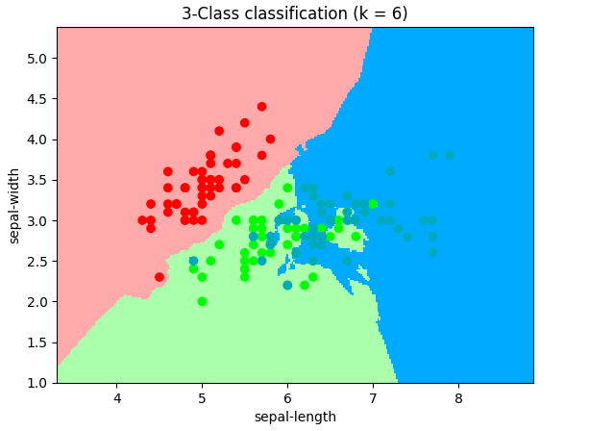

EX-10

import pandas as pd

import numpy as np

from sklearn.metrics import accuracy_score, confusion_matrix

from sklearn.model_selection import train_test_split

from sklearn.tree import DecisionTreeClassifier, export_graphviz

from six import StringIO

from IPython.display import Image

import pydotplus

import os

import matplotlib.pyplot as plt

# Read and print the training dataset

traindatainput = pd.read_csv('monks2_train.csv', delimiter=",")

print("Training Dataset")

print(traindatainput)

# Read and print the test dataset

testdatainput = pd.read_csv('monks2_test.csv', delimiter=",")

print("Test Dataset")

print(testdatainput)

# Define the feature columns and target column

X_train = traindatainput[['al', 'a2', 'a3', 'a4', 'a5', 'a6']].values

Y_train = traindatainput["label"]

X_test = testdatainput[['al', 'a2', 'a3', 'a4', 'a5', 'a6']].values

Y_test = testdatainput["label"]

# Split the data into training and testing sets

X_train, X_test, Y_train, Y_test = train_test_split(X_train, Y_train, test_size=0.3, random_state=3)

# Create a Decision Tree with criterion 'entropy' and max_depth 4

monksTree = DecisionTreeClassifier(criterion="entropy", max_depth=4)

monksTree.fit(X_train, Y_train)

predicted = monksTree.predict(X_test)

print(predicted)

# Find and print the accuracy of the decision tree model

print("Decision Tree's Accuracy:", accuracy_score(Y_test, predicted))

# Visualize the decision tree

dot_data = StringIO()

export_graphviz(monksTree, out_file=dot_data, filled=True, rounded=True, special_characters=True)

graph = pydotplus.graph_from_dot_data(dot_data.getvalue())

graph.write_png('tree.png')

Image(graph.create_png())

# Try different criteria and check accuracy

monksTree = DecisionTreeClassifier(criterion='gini')

monksTree.fit(X_train, Y_train)

pred = monksTree.predict(X_test)

print('Criterion=gini', accuracy_score(Y_test, pred))

monksTree = DecisionTreeClassifier(criterion='entropy')

monksTree.fit(X_train, Y_train)

pred = monksTree.predict(X_test)

print('Criterion=entropy', accuracy_score(Y_test, pred))

# Check if pruning can improve results

max_depth = []

acc_gini = []

acc_entropy = []

for i in range(1, 30):

monksTree = DecisionTreeClassifier(criterion='gini', max_depth=i)

monksTree.fit(X_train, Y_train)

pred = monksTree.predict(X_test)

acc_gini.append(accuracy_score(Y_test, pred))

monksTree = DecisionTreeClassifier(criterion='entropy', max_depth=i)

monksTree.fit(X_train, Y_train)

pred = monksTree.predict(X_test)

acc_entropy.append(accuracy_score(Y_test, pred))

max_depth.append(i)

d = pd.DataFrame({'acc_gini': pd.Series(acc_gini), 'acc_entropy': pd.Series(acc_entropy), 'max_depth': pd.Series(max_depth)})

# Visualize changes in parameters

plt.plot('max_depth', 'acc_gini', data=d, label='gini')

plt.plot('max_depth', 'acc_entropy', data=d, label='entropy')

plt.xlabel('max_depth')

plt.ylabel('accuracy')

plt.legend()

plt.show()

# Check accuracy with a shorter tree (max depth of 7) and criterion of entropy

monksTree = DecisionTreeClassifier(criterion='entropy', max_depth=7)

monksTree.fit(X_train, Y_train)

pred = monksTree.predict(X_test)

print("Accuracy after reducing depth and using Entropy:", accuracy_score(Y_test, pred))

EX-11

# Import libraries

import numpy as np

import pandas as pd

from sklearn.preprocessing import OneHotEncoder

from sklearn.model_selection import train_test_split

import sklearn.metrics

import matplotlib.pyplot as plt

# Load data

data = pd.read_csv(‘G:\AI ML\blood-transf.csv’)

data = data.sample(frac=1).reset_index(drop=True)

# Define X and Y

X = np.array(data)[:, 1:-1]

Y = np.array(data)[:, -1]

# One-hot encode Y

one_hot_encoder = OneHotEncoder(sparse=False)

Y = one_hot_encoder.fit_transform(np.array(Y).reshape(-1, 1))

# Split data into training and testing sets

X_train, X_test, Y_train, Y_test = train_test_split(X, Y, test_size=0.25)

# Define the neural network architecture

layers = [len(X[0]), 11, 8, 5, 5, len(Y[0])]

learning_rate = 0.1

epochs = 500

# Train the neural network

weights = NeuralNetwork(X_train, Y_train, X_test, Y_test, epochs=epochs, nodes=layers, lr=learning_rate)

# Print the final weights

print("Final weights:\n", weights)

# Test the model and print the accuracy

accuracy = Accuracy(X_test, Y_test, weights, display=True)

print("Testing Accuracy: {}".format(accuracy))

# Predict and evaluate

Y_result = [Predict(x, weights) for x in X_test]

Y_test = Y_test.tolist()

Y_result = [list(map(int, y)) for y in Y_result]

r2_score = sklearn.metrics.r2_score(Y_test, Y_result)

print("R2 score: {}".format(r2_score))

# Print the classification report

print(sklearn.metrics.classification_report(Y_test, Y_result))

# Compute and plot the ROC curve

fpr, tpr, thresholds = sklearn.metrics.roc_curve(Y_test, Y_result)

plot_roc_curve(fpr, tpr)

EX-12

import pandas as pd

import numpy as np

import matplotlib.pyplot as plt

from sklearn.utils import shuffle

from sklearn.model_selection import train_test_split

from sklearn.metrics import accuracy_score

# Load the dataset

df = pd.read_csv(r'G:\AI ML\breast_cancer.csv') # Fixed path by using r''

# Extract the feature values

X = df[['radius_mean', 'concavity_mean']].values

# Create separate datasets for open and high values

open_x = X[:50, 0]

open_y = X[:50, 1]

high_x = X[50:100, 0]

high_y = X[50:100, 1]

# Plot the data

plt.figure(figsize=(10, 8))

plt.scatter(open_x, open_y, marker='+', color='green', label='Open')

plt.scatter(high_x, high_y, marker='o', color='red', label='High')

plt.xlabel('Radius Mean')

plt.ylabel('Concavity Mean')

plt.legend()

plt.show()

# Extract target values (diagnosis) and convert to -1 or 1

Y = df['diagnosis'].map({'M': -1, 'B': 1}).values

# Drop diagnosis column from the dataframe

df = df.drop(['diagnosis'], axis=1)

# Shuffle the data

X, Y = shuffle(X, Y)

# Split the data into training and test sets

X_train, X_test, Y_train, Y_test = train_test_split(X, Y, train_size=0.9)

# Initialize parameters

w1 = np.zeros(1)

w2 = np.zeros(1)

epochs = 10000

alpha = 0.0001

# Training the SVM using gradient descent

for epoch in range(epochs):

y = w1 * X_train[:, 0] + w2 * X_train[:, 1]

count = 0

for val in y:

if val >= 1:

cost = 0

w1 = w1 - alpha * (2 * (1 / epochs) * w1)

w2 = w2 - alpha * (2 * (1 / epochs) * w2)

else:

cost = 1 - val

w1 = w1 + alpha * (X_train[count, 0] * Y_train[count] - 2 * (1 / epochs) * w1)

w2 = w2 + alpha * (X_train[count, 1] * Y_train[count] - 2 * (1 / epochs) * w2)

count += 1

# Clip the weights

index = list(range(10, X_train.shape[0]))

w1 = np.delete(w1, index)

w2 = np.delete(w2, index)

# Extract the test data features

test_fl = X_test[:, 0].reshape(-1, 1)

test_f2 = X_test[:, 1].reshape(-1, 1)

# Predict

y_pred = w1 * test_fl + w2 * test_f2

predictions = np.where(y_pred > 1, 1, -1)

# Calculate and print the accuracy

accuracy = accuracy_score(Y_test, predictions)

print("Accuracy: ", accuracy)

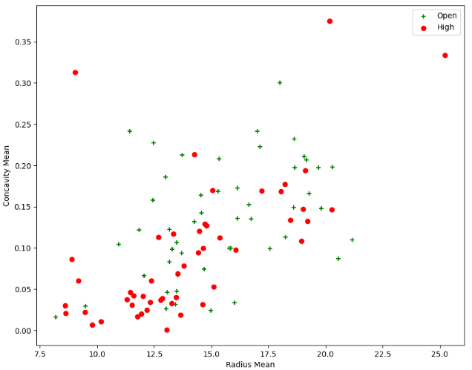

EX-13

import pandas as pd

import numpy as np

import matplotlib.pyplot as plt

# Load the dataset

data = pd.read_csv("G:\AI ML\diabetes-1.csv")

# Check the shape and first few rows of the dataset

print(data.shape)

print(data.head())

# Separate features (X) and target variable (Y)

X = data.drop(['SkinThickness', 'Outcome'], axis=1)

Y = data['Outcome']

# Split the data into training and testing sets

from sklearn.model_selection import train_test_split

X_train, X_test, y_train, y_test = train_test_split(X, Y, test_size=0.2, random_state=42)

# Import the logistic regression model

from sklearn.linear_model import LogisticRegression

# Create a logistic regression classifier

clf = LogisticRegression()

# Train the model on the training data

clf.fit(X_train, y_train)

# Predict the response for the test dataset

y_pred = clf.predict(X_test)

# Import the accuracy metric

from sklearn.metrics import accuracy_score

# Calculate and print the accuracy of the model

print("Accuracy:", accuracy_score(y_test, y_pred))

**Output**

(767, 9)

Pregnancies Glucose BloodPressure SkinThickness Insulin BMI \

0 6 148 72 35 0 33.6

1 1 85 66 29 0 26.6

2 8 183 64 0 0 23.3

3 1 89 66 23 94 28.1

4 0 137 40 35 168 43.1

DiabetesPedigreeFunction Age Outcome

0 0.627 50 1

1 0.351 31 0

2 0.672 32 1

3 0.167 21 0

4 2.288 33 1

Accuracy: 0.7857142857142857